**What we have done:**

Meeting with Meng Qu on Monday and confirm the data that we could get from the library (including computer and book)

**What we are doing:** 1. Looking research paper for a better solution of mapping

2. Drawing the map (grid map) by CAD software

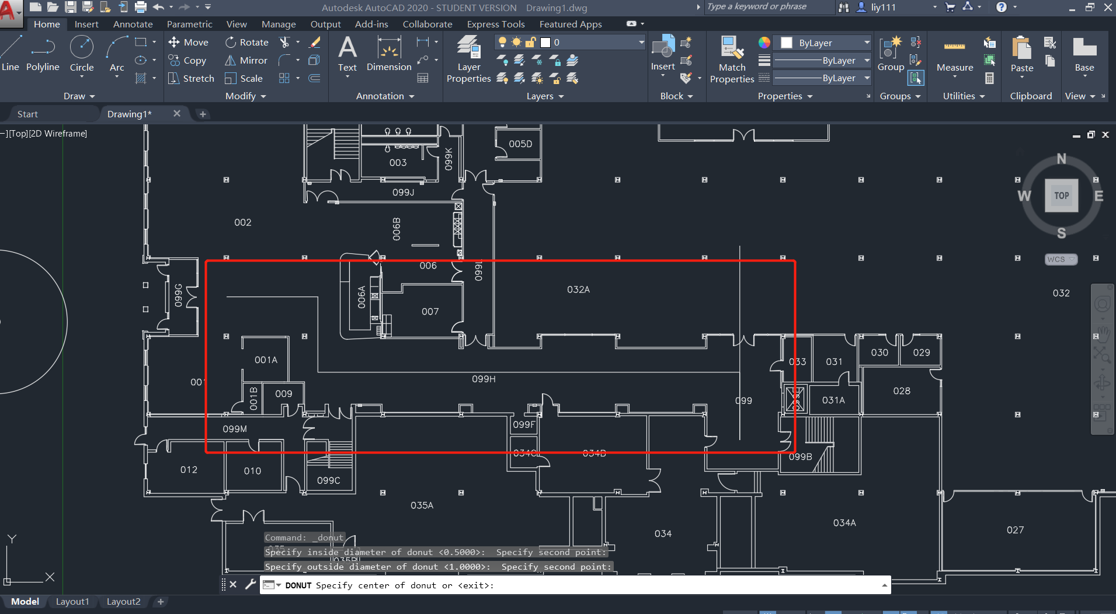

3. Coding on an algorithm based on A* (assuming we use grid map as our data)

**What we are going to do:**

Start building the App interface.

**Conclusion:**

Our progress is very slow since we currently do not have any knowledge or suitable research solution to build a mapping system, as long as we have a 100% executable solution, the progress will be much faster.

**Note: bring a document about what our group is focusing (many obstacles...)**